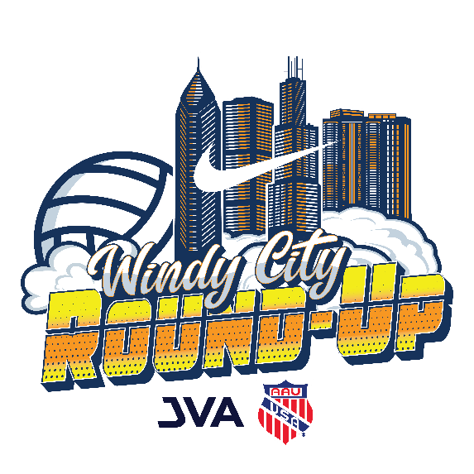
2026 AAU/JVA Windy City Round-Up

DATES:
Friday, June 19, 2026
Saturday, June 20, 2026
Sunday, June 21, 2026

VENUE:
McCormick Place
2301 S. Dr. Martin Luther King Jr. Drive
Chicago, IL

COMPETITION LEVEL
Boys 13U – 18U
Open
Premier
Classic

HEAD REFEREES
Jim Arts
Joseph O’Neal

ASSIGNOR
Angela Hummeldorf

HOTEL COORDINATOR
Peg O’Neal

REGISTRATION
https://www.advancedeventsystems.com
2026 AAU/JVA Windy City Round-Up

REFEREE PAY
National $47.00
Jr. National $45.00
Regional $42.00
Provisional $40
Not Rated $35.00

REFEREE PAYMENT
Arbiter Pay = information should be on AES
Referee Certification = information on AES
Check with completed W-9
NUMBER OF TEAMS
300+

NUMBER OF COURTS
52

REFEREE UNIFORM
Certified Official Polo: Blue, gray, or white
AAU or JVA-branded polo shirt
Saturday: Hawaii shirt
Outerwear: Certified Official or AAU / JVA-branded gear

Work Schedule
Posted on https://jposports.com/windy-city-round-up
Emailed to all officials the night before

MEALS/SNACKS & WATER
Vouchers for each wave worked (Friday -2, Saturday – 2, Sunday -1)
Snacks and bottled water provided
You may also bring your own snacks discreetly
A microwave will be in the officials work-room

PARKING/TRANSPORTATION
JVA will help offset parking or airfare to a maximum of $75
Receipts – send a picture to hotels@jposports.com by Monday, June 22, at noon.
Use Spot Hero to reserve your parking space
Visit the McCormick Place SpotHero Parking page

COMMUNICATION
joseph@jposports.com preferred email
hotels@jposports.com is for housing and transportation receipts
Joseph (270) 993-2217
Jim (262) 893-6629
Angela (859) 802-3201
We do not monitor the AES Head Official emails

